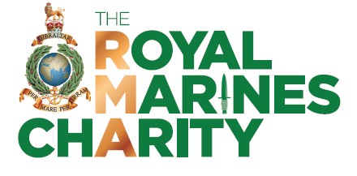

**Royal Marines Charity Golf Day – Thu 6th Jun 24**

**ENTRY FORM – please complete and email back – see instructions below**

**Competition**

Teams of 2, in 4-ball format, Stableford scoring. 90% handicap allowance.

Handicaps: Men max 28, Ladies max 36. H’Cap will be adjusted on the day for course.

**Personal Details - 1 to 4 players**

Player 1 Name/HCap: Player 3 Name/HCap:

Player 2 Name/HCap: Player 4 Name/HCap:

Exeter Golf and Country Club Member: Yes/No Membership Number:

RMA Golf Society Member: Yes / No

Preferred Tee Time: AM. PM. Tick preferred slot. Window 09.00-15.00

Contact Email Address: Contact Telephone Number:

**Payment Details**

Cost for the day is £65 per player, unless you are a member of Exeter Golf and Country Club, in which case it is £45.

Please pay direct to bank: Lloyds Bank Acct Name: Royal Marines Association Golf Society

Sort Code: 30-80-37 Bank Account: 14458162

Please use Reference: RM Charity Golf 2024

**Sponsorship**

If you would like to sponsor a hole, please contact Paul Denning on [p.denning@thermcharity.org](mailto:p.denning@thermcharity.org) . Cost of sponsorship is £200/major hole (1st, 8th, 18th) and £100/minor. A major sponsor is also sought. Please contact Paul if interested.

**Reply**

Please send this completed form back to [wc100golf@gmail.com](mailto:wc100golf@gmail.com) and make payment direct to the bank account above.

Tee times will be allocated and notified to you on receipt of payment.

Note: If for any reason you cannot use email or electronic bank payment, please contact [wc100golf@gmail.com](mailto:wc100golf@gmail.com) for alternative ways to book and pay.

..

